Competitive Shooters of Lake Norman USPSA January 16th, 2026
COURSE DESIGNER: Ryan Christenson
START POSITION: See written stage briefings.

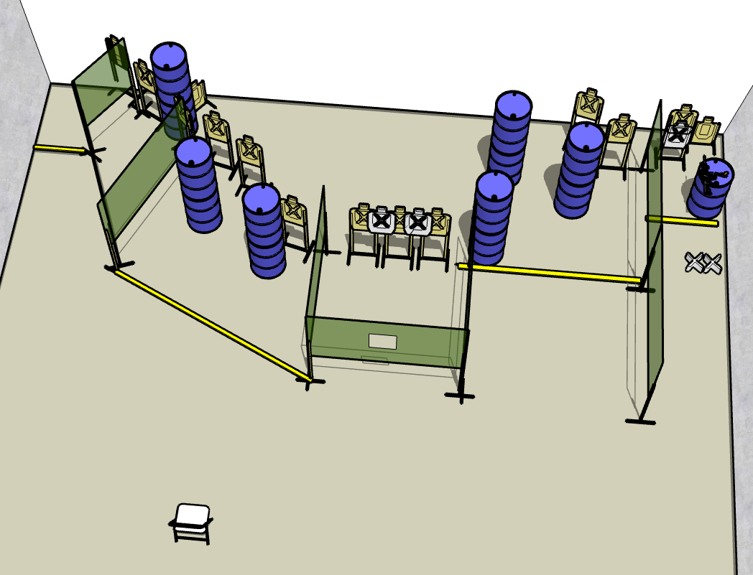

Written Stage Briefing:

Stage 1 – Feeding Our Future
Comstock
28 rounds. 14 paper targets. Some no shoots.
Feet on XXs. Gun is unloaded and placed unpropped on barrel. First magazine / reloading device placed on barrel.
On the audible start signal, engage targets from within the shooting area.
Stage 3 – Quality Learing Center
Comstock
30 rounds. 15 paper targets. Some no shoots.
Sitting in chair. Back must be touching the chair. Handgun is loaded and holstered. PCC loaded held in both hands.
On the audible start signal, engage targets from within the shooting area.

